LO7 – SELECT Statement

Select is used to query the database. The result set is simply another table (dynamically created from our database).

* SELECT – Simplest form syntax:
* Specifying columns
* Full Syntax:
* Operators in SQL
* Sorting the results

# Group or Aggregate Functions

* Aggregate functions return a single result row based on groups of rows, rather than on single rows.






* The functions are:
  + SUM
  + AVG
  + COUNT
  + COUNT(*)
  + Max/Min
* GROUP BY and HAVING Clauses

# Joining Tables

* With normalization, we break related information into multiple tables. We use joins to put the tables back together.

General rules to get meaningful results with joins:

Join Syntax:

Join Operator



Types of joins:

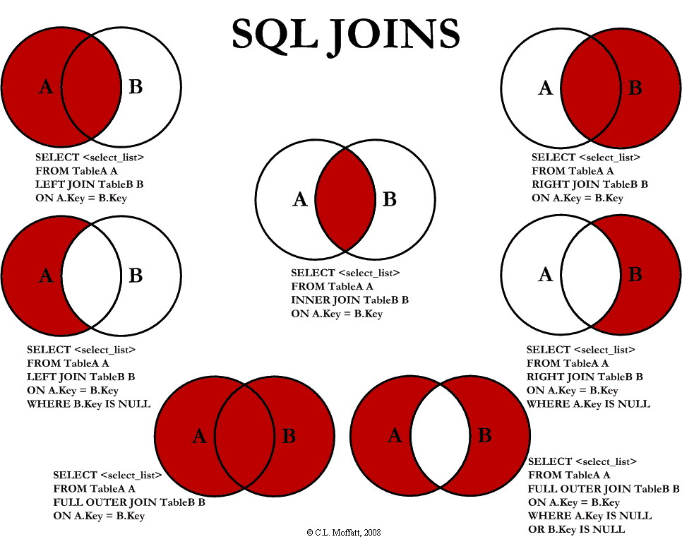

# Set Operators – UNION, INTERSECT, and MINUS